Lab 8

Data blending in Tableau Data blending
Q1: Create a bmp image file from sheet3, containing a meaningful title and caption, and insert it into your document.
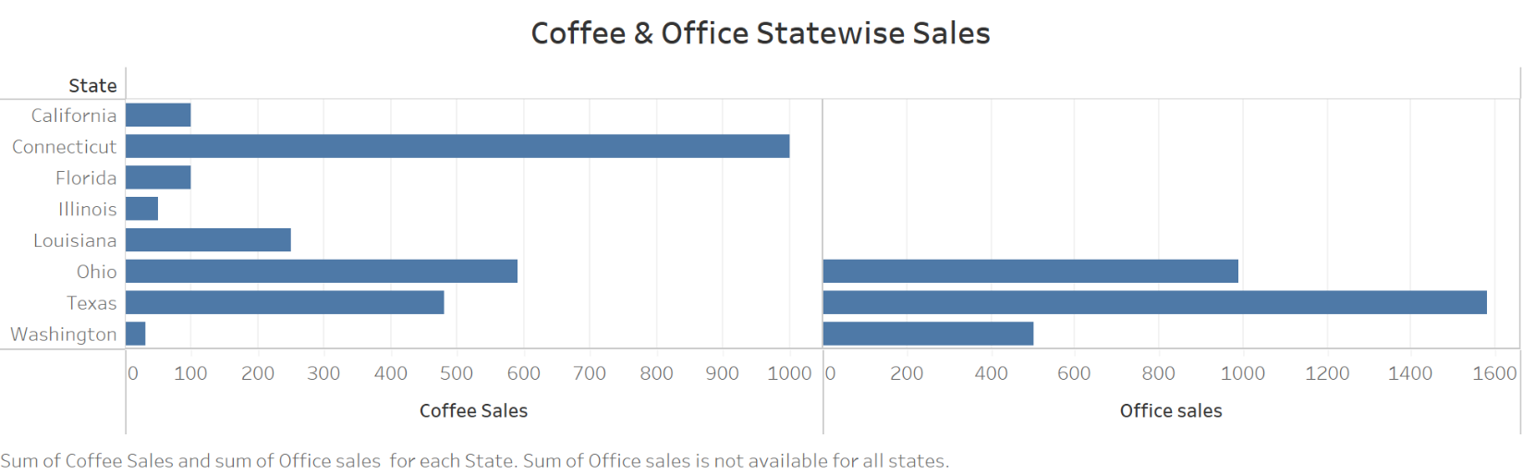

Data blending
Q2: Create a bmp image file from sheet4, containing a meaningful title and caption, and insert it into your document.
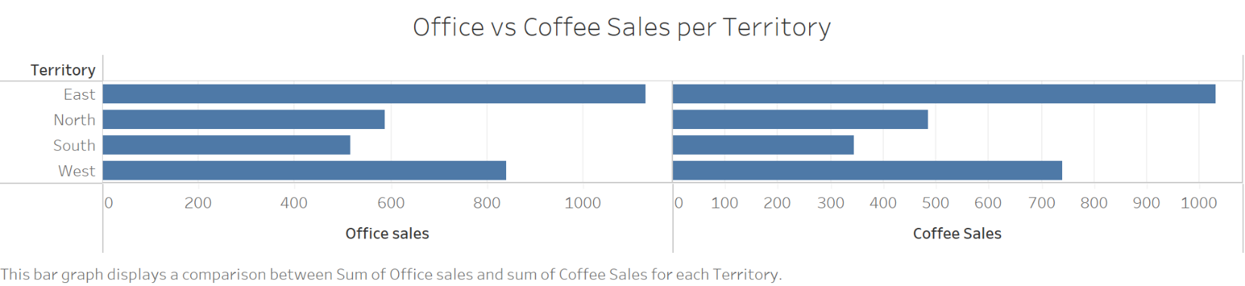

Q3: What is the amount of “Office Sale” done and “Coffee Sales” done in the “South” region?
The amount of “Office Sales” in the “South” region is 516.0 while the “Coffee Sales” in the “South” region is 345.

Data blending calculations Data blending calculations
Q4: Create a bmp image file from sheet5, containing a meaningful title and caption, and insert it into your document.
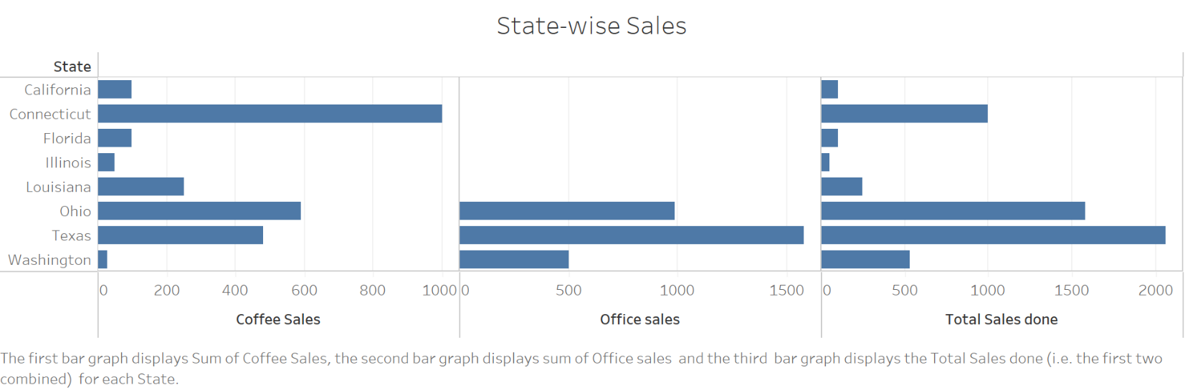

Bubble charts Bubble charts
Q5: Which state has the highest “Sales” done? How much is it? Create a bmp image file from sheet4, containing a meaningful title and caption, and insert it into your document.
The “State” that has the highest sales is California. The amount of sales made in California is 1,161,721.
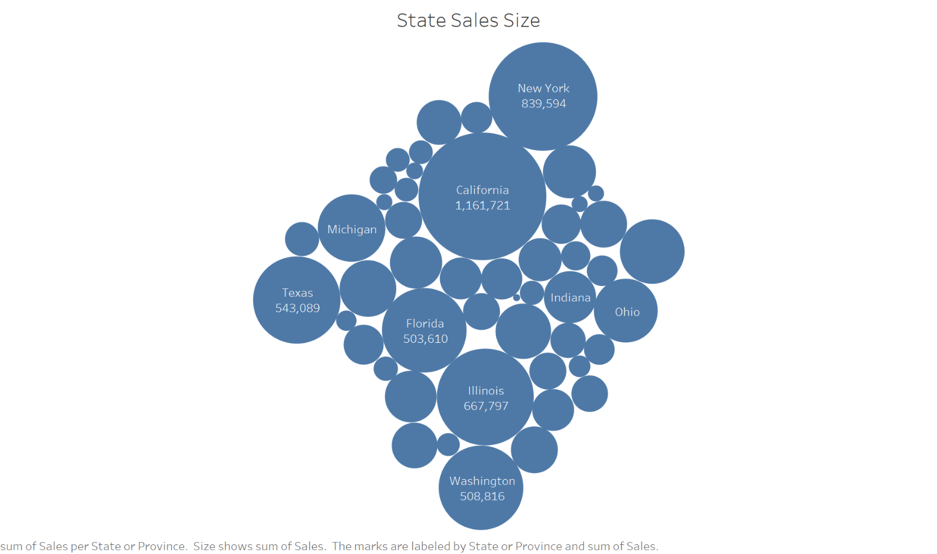

Bar Chart and Stacked Chart Bar charts
Q6: Which “Category” in which “Region” has the lowest “Sales” done? How much is it? Create a bmp image file from sheet6, containing a meaningful title and caption, and insert it into your document.
The Office Supplies “Category” in the South “Region” has the lowest “Sales” done. The amount of sales made is 373,951.
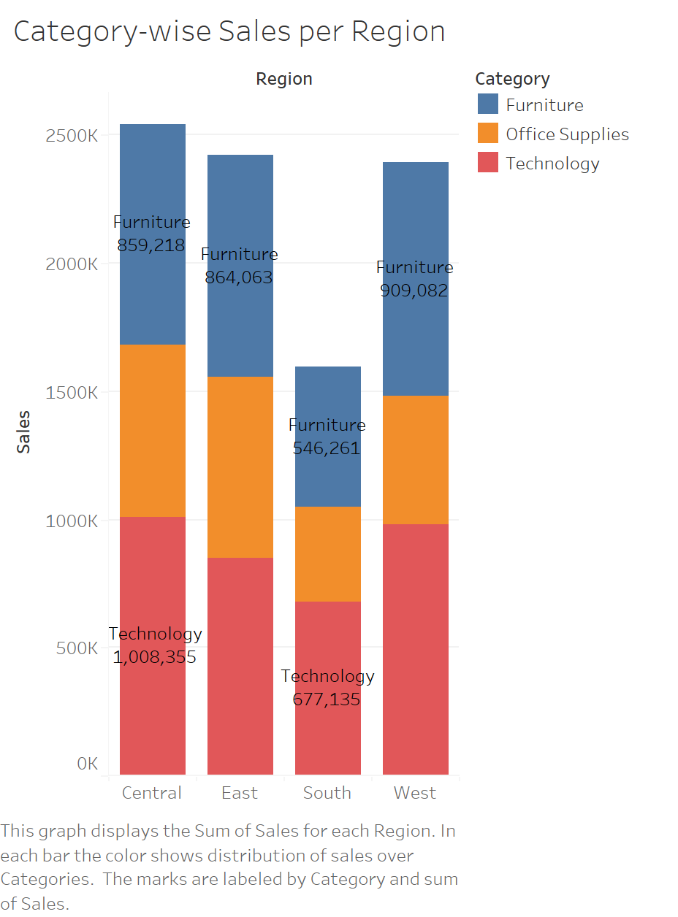

Leveled bar graphs.
Q7: Which “Category” has the most “Sub-Category” ? How many it has? Create a bmp image file from sheet8, containing a meaningful title and caption, and insert it into your document.
The following bar graphs are obtained by interchanging the category filter. The “Category” has the most “Sub-Category” is Office Supplies. The Office Supplies Category has 9 subcategories.
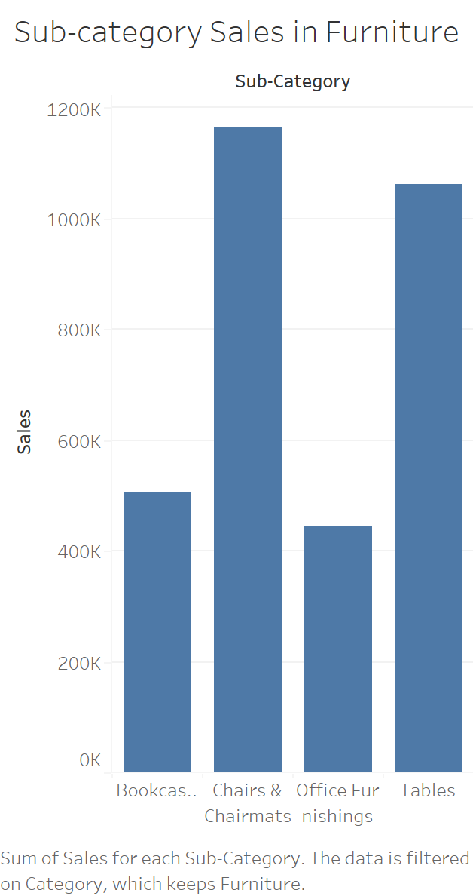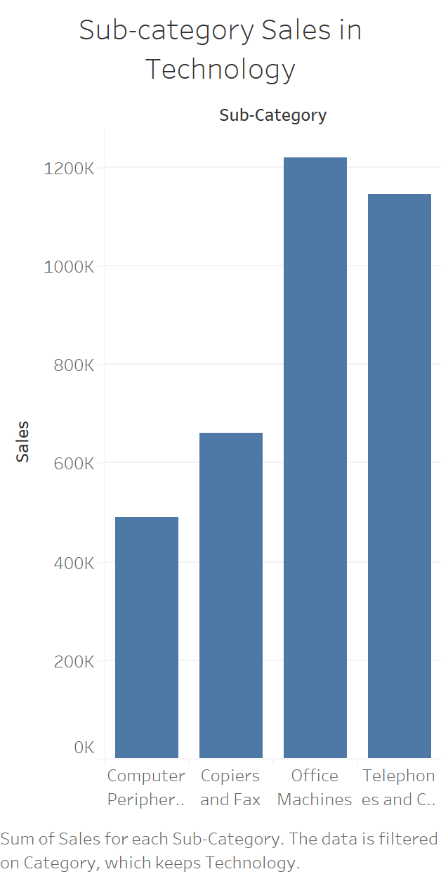

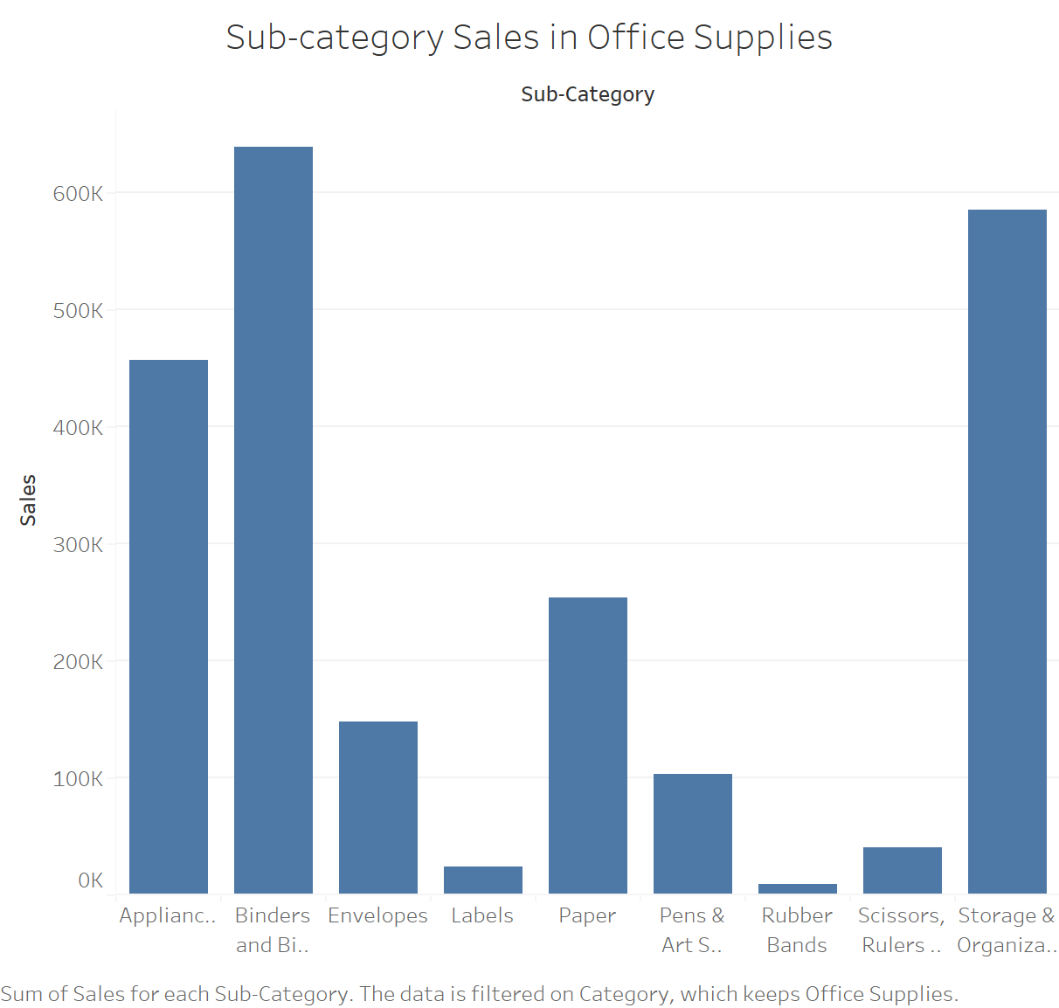

Tree maps Tree maps
Q8: Create a bmp image file from sheet10, containing a meaningful title and caption, and insert it into your document.
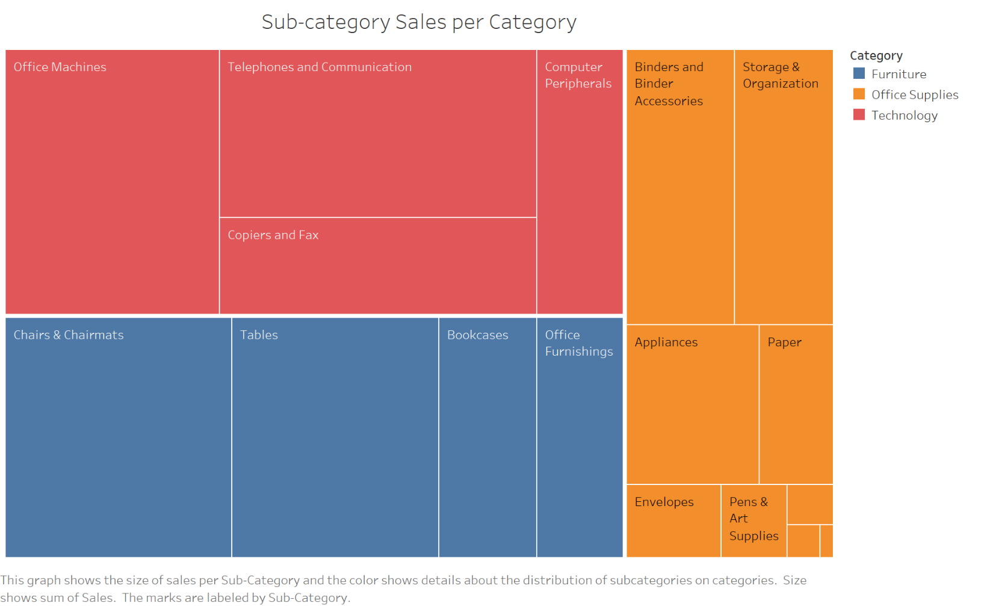

Q9: Which “Sub-Category” has the lowest “Profit”? How much is it? Create a bmp image file from sheet11, containing a meaningful title and caption, and insert it into your document.
The “Subcategory” that has the lowest profit is Tables. The amount of profit is -72,495.
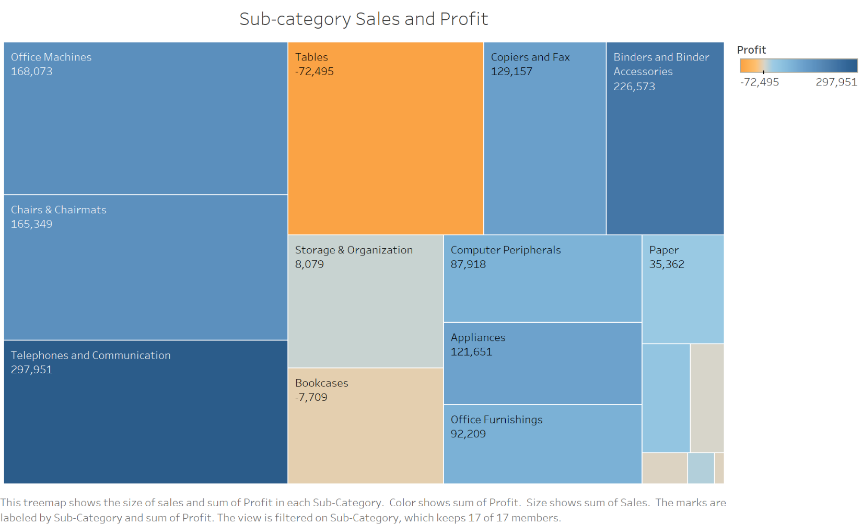

Bump chart Bump chart
Q10: In 2010, which “Region” has the third rank of “Sales”? In 2013, which “Region” has the first rank of “Sales”? Create a bmp image file from sheet13, containing a meaningful title and caption, and insert it into your document.
In 2010, the “Region” that had the third rank of “Sales” is the central region. In 2013, the “Region” that had the first rank of “Sales” is also the central region.


